ASSIGNMENT NO: 03

AIM: To build a cloud – ready temperature sensor with the Node MCU and any IoT
Platform.

Objective:
- To understand interfacing of temperature sensors.
- To log and monitor temperature data over internet using Things Speak IoT server.

Theory:
- Write description of Node MCU i.e. ESP8266.
The Node MCU (Node Micro Controller Unit) is an open-source software and hardware development environment built around an inexpensive System-on-a-Chip (SoC) called the ESP8266. The ESP8266, designed and manufactured by Es press if Systems, contains the crucial elements of a computer: CPU, RAM, networking (Wi Fi), and even a modern operating system and SDK. That makes it an excellent choice for Internet of Things (IoT) projects of all kinds. However, as a chip, the ESP8266 is also hard to access and use. You must solder wires, with the appropriate analog voltage, to its pins for the simplest tasks such as powering it on or sending a keystroke to the “computer” on the chip. You also have to program it in low-level machine instructions that can be interpreted by the chip hardware. This level of integration is not a problem using the ESP8266 as an embedded controller chip in mass-produced electronics. It is a huge burden for hobbyists, hackers, or students who want to experiment with it in their own IoT projects.
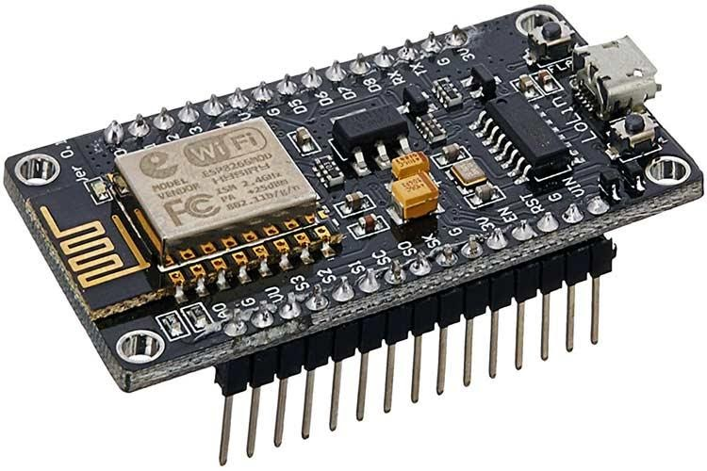

- Write description of LM35/DHT11.
LM35 is a temperature sensor that outputs an analog signal which is proportional to the instantaneous temperature. The output voltage can easily be interpreted to obtain a temperature reading in Celsius. The advantage of lm35 over thermistor is it does not require any external calibration.

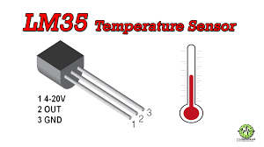

Conclusion: After the study of this assignment we are able to perform operations on Node MCU and able send data on cloud.

